New Games Night…

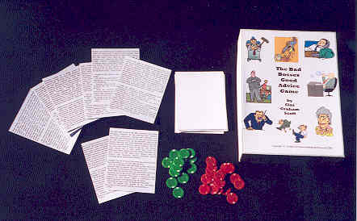
Have fun playing all kinds of new social interaction, discussion, and communication games.

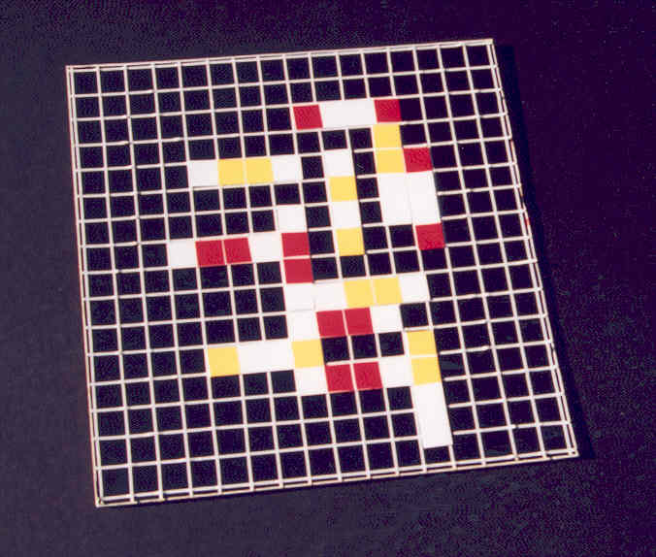
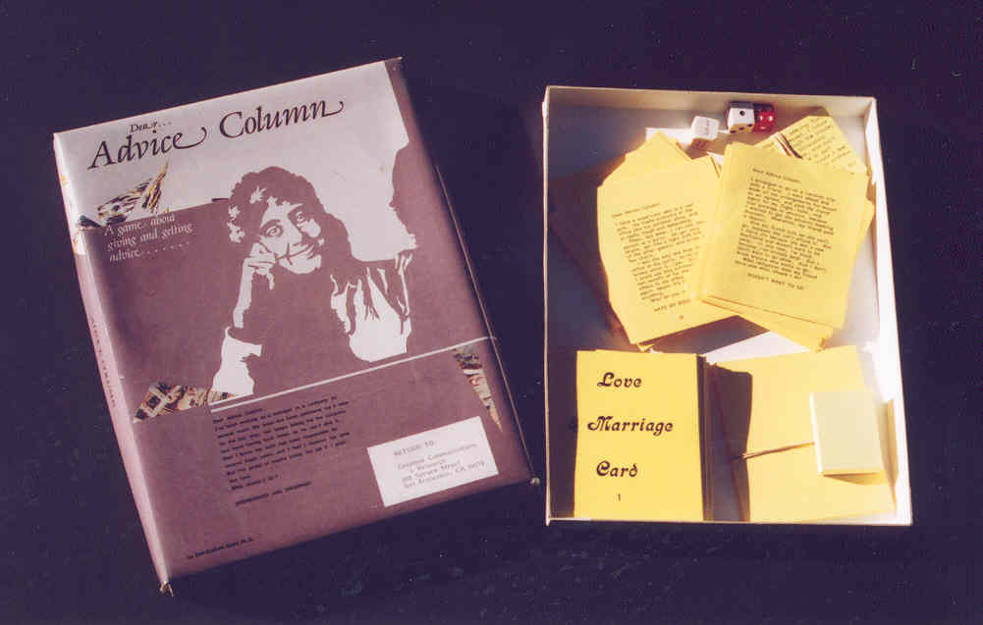
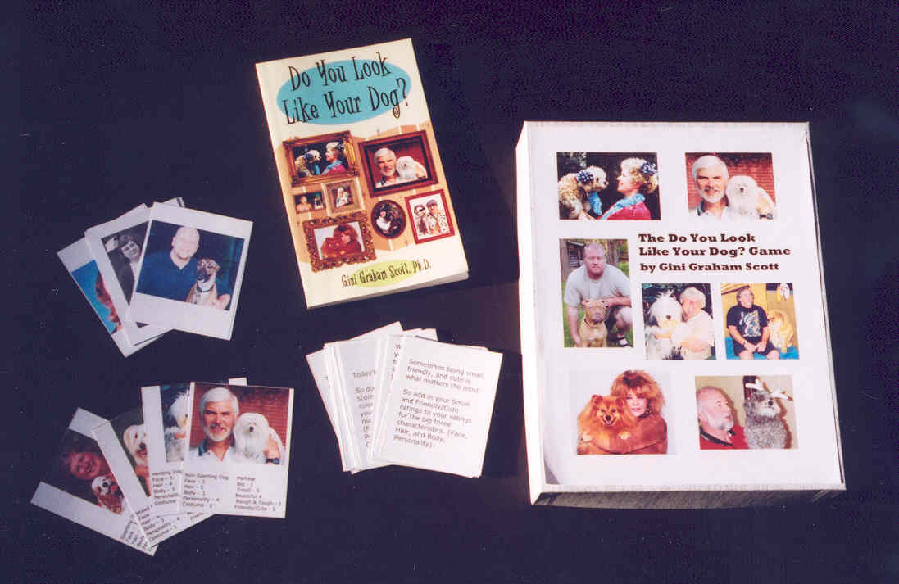
We’ll set up a program for your organization. We’re also looking for small groups of 3-8 people who would enjoy trying out our games. No charge. Just get together some friends and neighbors, and we’ll bring the games for a unique evening of fun.

Interested? For more information, contact:
CHANGEMAKERS
6114 La Salle, #358 . Oakland, CA 94611
(510) 339-1625 . changemakers@pacbell.net

